New Campaign Primer:

The Blue Planet

Table of Contents
- About the Campaign and its Construction
  - AI Use
  - Balance and Character Death
  - Rules and Other Notes
- About the Setting
- Allowed Species and Classes
- Character and Party Construction
- Conclusion

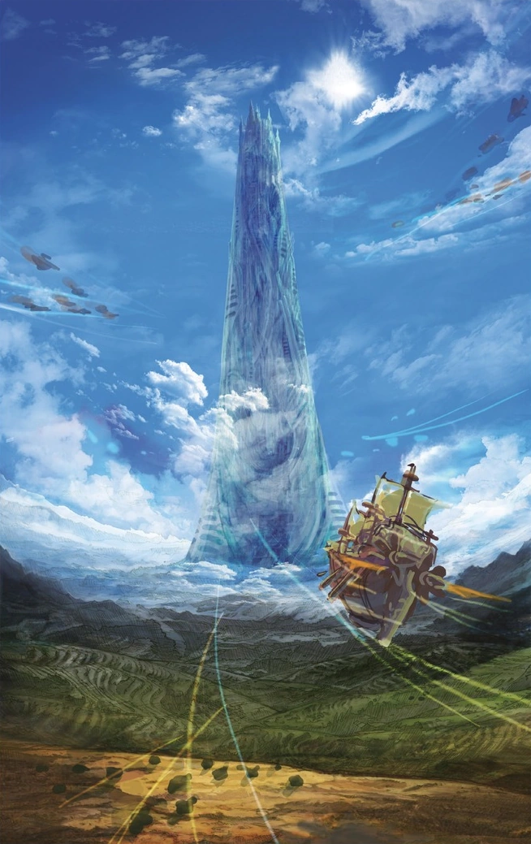

About the Campaign and its Construction

AI Use
Hi! I’m very excited that you finally have a chance to read this! Running this campaign is something I’ve really wanted to do for y’all for a very long time. Until recently, though, the amount of expertise and effort it would have taken to make something like this a reality put it far, far out of reach for many years.
However, with the invent of LLMs and agentic AI, putting together all the pieces of a homebrew campaign is finally within reach for a mere mortal (me). I am no Mercer or Mulligan – and so I leaned heavily on AI to help me construct parts of the campaign. I don’t think AI use is a hot button issue for you folks, but as the issue of AI and data centers becomes increasingly debated, I wanted to be up front that I used AI to help me make this campaign. A lot.
My most frequent use of AI was to create battle maps. In fact, nearly every map we’ll play on in this campaign was generated by an AI. This means that, of course, from time to time there will be these incongruences that we’ll work out together as DM and Players. For example, a stray chest in the corner of a room might be intentionally placed or might be unintentional and something I missed. Either way, feel free to investigate such things with your characters – I’ll be straightforward with you if something is AI garbage and not worth bothering.
The second most frequent use of AI in this campaign was to create stat blocks for custom monsters. I discovered that Claude is very, very good at creating these – it was minimal work for me to ask for what I wanted and to get a quality product out of it. Only occasionally did I have to tweak for balance. This is something that I don’t think you’ll notice over the course of the campaign.
If it matters to you, most of the other parts of the campaign that are homebrew (subclasses, magic items, feats, story points) were by and large my own invention, with minimal (though not zero) AI involvement.

Balance and Character Death
In this campaign, I used the new Combat Encounter Difficulty rules in the 2024 DMG. Although it’s impossible to say before running anything, my opinion is that the encounters are by and large far more difficult than the suggestions in the 2014 DMG. There were multiple times I looked at the monster/combat I created and thought “oh, this is gonna be brutal.” Nonetheless, I stuck to the guidelines.
I think Lee and I generally have a high opinion of your competency as players; I think that hypothesis will be put to the test repeatedly. More than ever in this campaign, I think carelessness could get you killed.
That, however, might be a problem. This campaign plans to be highly character-driven. In a stock campaign, you usually must manufacture some sort of backstory or reason why your character is around to begin. This is my campaign, though, and I’m going to have a heavy hand in character backstory and background construction, to precisely fit the story I want to tell. Of course, that means that character death has the potential to be traumatic – or even fatal - to the plotline.
As we start the campaign, I hope I quickly get a feel on if I’ve over-tuned the combats. If a combat truly goes south and we end up something like a TPK, I refuse to let it be the end of the story. How I resolve it will remain intentionally up in the air.

Rules and Other Notes
- We’ll be using 5.5e rules.
- I may choose to use some of the 5e rules I like better (example: contested Athletics/Acrobatics checks). Two things I am a stickler for:
  - Spell components. Make sure you’ve paid for them if you want to cast spells that need them (like Identify).
  - Hands. Be aware of the hand requirements for casting spells, holding weapons, or holding light sources.
- This campaign will make heavy use of Sidekicks, using the Sidekick rules from Tasha’s Cauldron of Everything. I really like having meaningful NPCs like Api around!

About the Setting
The name of the campaign is the same as the name of the characters’ home – the Blue Planet. For now, you may think of the Blue Planet as no different than the Forgotten Realms, or Aglarion – it is a traditional fantasy world in the same style with which we are familiar. However, let’s go over some key differences in my setting:
- As far as anyone knows or believes, there are no gods on the Blue Planet. As such, there are no clerics. This is not to say that the cleric class is unavailable (look at the Allowed Species and Classes section for more information), but that on the Blue Planet, divine magic is merely a different branch of Magic utilizing Wisdom – not divinely inspired. Citizens on the Blue Planet might still pray to things like the sun or moon (much like our own world!) but there is no real, conclusive evidence of deities. Mechanically, this means:
  - There is no need to take the Religion skill.
- In the Forgotten Realms (Aglarion too?), magic is old. Adventurers come across relics of the past, finding powerful artifacts and casting time-tested spells. However, in the world of the Blue Planet, magic is new. Many spells have only recently been discovered. Magic items are only just starting to be manufactured, and everyone can see the potential. The future is waiting for the new advances of magic to shape it. Mechanically, this means a few things:
  - Not every spell in the handbooks will be available for player choice. Specifically, these two categories of spells simply do not exist yet on the Blue Planet:
    - Spells that bring people back from the dead (with the exception of Revivify)
    - Spells that teleport you great distances
  - As such, I reserve the right to ban other spells that I discover are disruptive to the story I want to tell.
  - On the other hand, if you’ve ever thought about exercising the creativity to create your own spell as a spellcaster, this campaign might be the perfect opportunity to lean into the story and do so!
- Humans are the only good sentient race on the Blue Planet. As far as anyone knows, there are no such things as elves or dwarves, although there are certainly evil ogres, trolls, goblins, bugbears, and the like in the Tolkien sense. Additionally, humans across the Blue Planet speak the same language, Common. Mechanically, this means:
  - There is no need to take languages like Elvish or Dwarven.
  - Spells like Comprehend Languages might have less utility than normal.
  - Although there are no gods, there still might be things like angels and demons, and different planes.
  - In general, if you’ve made a pointless choice in character creation, I’ll tell you to make another choice.
- Feel free to ask me more questions about the setting – I will be as verbose as I am able without revealing spoilers.

Allowed Species and Classes
For the purpose of thinking about what you want to play, know that this campaign will start at Level 3, when everyone selects their subclass, and will end somewhere between Levels 11-13. No multiclassing will be allowed – with one specific exception you can read about below. The following lists are exhaustive – if a class or subclass doesn’t appear here, it is not available for play.
I have created several homebrew subclasses for your enjoyment as well. Pay particular attention to the Fighter’s Dark Knight subclass. Soon, I will be sending a survey to discover what people want to play in this campaign. It will be a campaign requirement that exactly one player selects the Dark Knight subclass. The player who chooses the Dark Knight subclass will have a larger roleplaying and plotline responsibility and will accept more DM involvement in their character creation and leveling. Feel free to chat with me for more details about accepting this challenge!

Available Species
- Human (Lee’s dream!)

Available Classes/Subclasses
All classes/subclasses are their 5.5e versions unless otherwise noted.

Artificer (as found in Eberron: Forge of the Artificer)
- Armorer
- Artillerist
- Battle Smith
- Cartographer

Barbarian
- Path of the Berserker
- Path of the Blue Planet (reskinned; Path of the World Tree)

Bard
- College of Lore
- College of the Moon
- College of Valor

White Wizard (reskinned; Cleric)
Nothing mechanically will change about the cleric. On the Blue Planet, they are simply referred to as “White Mages” or “White Wizards”, and they get their abilities by hard work and study, just like traditional wizards. (Wisdom is still the white wizard’s casting stat.)
- Life Domain
- Light Domain
- War Domain
- Arcana Domain *new in Arcana Unleashed*

Druid
- Circle of the Land
- Circle of the Stars

Fighter
Exactly one player must choose to be a Dark Knight.
- Battle Master
- Champion
- Eldritch Knight
- Homebrew: Dark Knight

Monk
- Warrior of Mercy
- Warrior of Shadow (recommend starting Rogue 1 – only allowed multiclass)
- Warrior of the Open Hand
- Warrior of the Mystic Arts *new in Arcana Unleashed*

Ranger
- Hunter
- Homebrew: Wyvern Knight (reskinned; the Drakewarden from Fizban’s Treasury of Dragons, updated to 5.5e)

Rogue
- Arcane Trickster
- Assassin
- Thief

Black Wizard (reskinned; Wizard)
As White Wizards are the traditional clerics, Black Wizards are the traditional wizards.
- Abjurer
- Diviner
- Evoker
- Illusionist
- Conjurer *new in Arcana Unleashed*
- Transmuter *new in Arcana Unleashed*

Character and Party Construction
Soon, I will send the players a survey asking for a ranked list of your top 3 subclasses for this campaign. After receiving this list from everyone, I will do my best to assign subclasses according to your interests. Of course, feel free to discuss amongst yourselves as well. I will intentionally balance the party subclass choices using your ranked lists if I need to.
Once I know everyone’s subclasses, I will set about integrating your character into the campaign. I will create a custom background for every character with a custom Origin feat. (Since you are Human, you may freely choose whatever other Origin feat you’d like.) I’ll make sure the custom feats match the interest you have in your character vis a vis stat increase and skill choices.
As you create your new character, I’ll work very closely with you to establish your backstory and place on the Blue Planet. Maybe you’ll have some secrets, or some nearby family, or any number of other tidbits. I also want you to give serious thought to what your character looks like – their height, weight, hair color, eye color. We live in an era where we can make character portraits to precisely realize our mind’s image.
An advantage of establishing “canon” art for each of the PCs early on is that it will enable me to use those images to potentially create AI recaps using those portraits (example: the silly images I make during/after sessions of Crown of the Oathbreaker.)
Some other things:
- I’ll remind you that you will be making Good characters. It’s your choice whether you’d like to be Lawful/Neutral/Chaotic.
- Let’s stick to adults for this campaign.

Conclusion
That’s it for now! Although I’ve laid out a lot of guidelines above, I want to stress that I’m happy to work with your re: character creation if you have a specific idea in mind. Looking forward to it!

